B21
This cybersecurity learning activity is designed to teach users about password security. Passwords are one of the most common methods used to protect accounts and systems. Weak passwords can be easily guessed or cracked by attackers, which may lead to unauthorized access. Therefore, users must understand how to create strong passwords.
The activity is implemented as a simple password strength checker using Python. The user enters a password, and the program checks it based on common security rules. These rules include password length, use of uppercase letters, lowercase letters, numbers, and special characters. Based on these conditions, the program calculates a score and classifies the password as weak, medium, or strong.
The activity also provides suggestions to improve weak or medium passwords. For example, if a password does not contain numbers or symbols, the user is advised to add them. This makes the activity educational because users not only receive a result but also learn how to improve their password security.
This activity is useful for beginners because it is simple, interactive, and easy to understand. It helps users learn the importance of strong passwords through practical testing. Instead of only reading about password safety, users can test different passwords and immediately see the result.
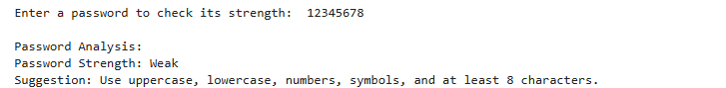
In conclusion, the password strength checker is an effective cybersecurity learning activity. It teaches users how password complexity affects security and encourages them to create stronger passwords. This can help reduce the risk of account compromise and improve overall cybersecurity awareness.

